 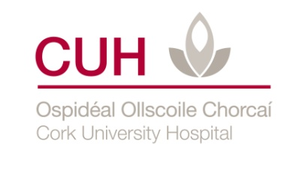

**Physiotherapy Department**

# 

**Cough-Assist Machine**

**Patient information leaflet**

**What is a Cough Assist Machine?**

A cough assist machine is a respiratory device that you can use regularly for keeping lungs clear of secretions. People with weak breathing muscles use this device as an exerciser for the lungs. Positive pressure inflates the lungs and negative pressure assists in moving secretions if present.

This machine will help you take deep breaths, give a stronger cough and help you to clear your chest.

This machine will be set up by a company called Respicare. They will contact you to arrange a time that suits you to deliver it to your home. Your community physiotherapist will also be contacted to inform them of the date for delivery.

The machine is identical to the one you tried in the hospital. The settings will be programmed to exactly match those prescribed by your physiotherapist in the clinic.

**The benefits of using a Cough Assist Machine?**

* Keeps the lungs clear of secretions
* Helps prevent chest infections from developing
* Keeps lungs and chest wall flexible
* Makes it easier to cough effectively
* Improves voice strength

**What equipment is needed?**

* Cough assist machine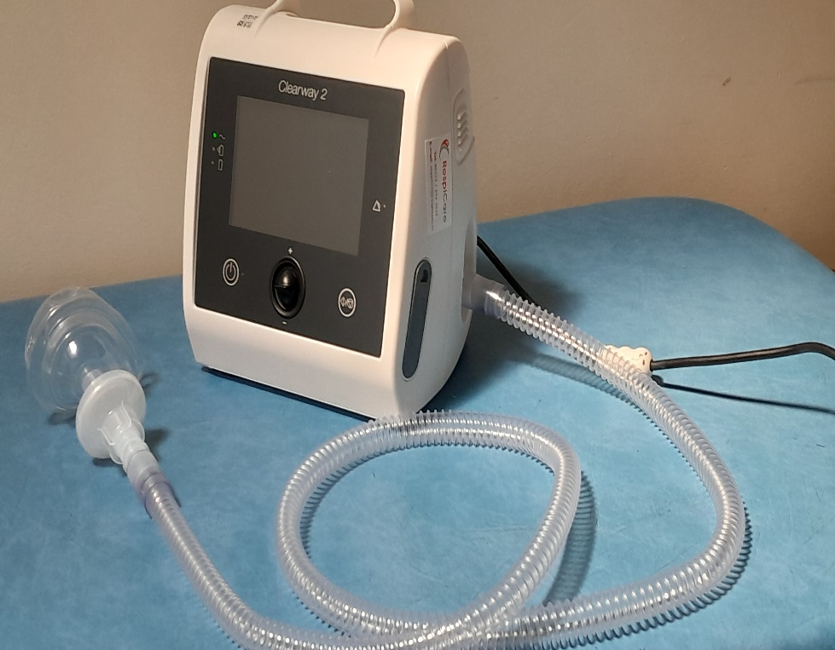

Start/Stop

On/Off

Tubing

Filter

Face-mask

* Face Mask
* Tubing & Filter

This will be demonstrated and assembled by your physiotherapist and representative from Respicare.

**Caution**

Do not share cough assist machine equipment with anyone as this could spread infection.

**Using Cough-assist machine**

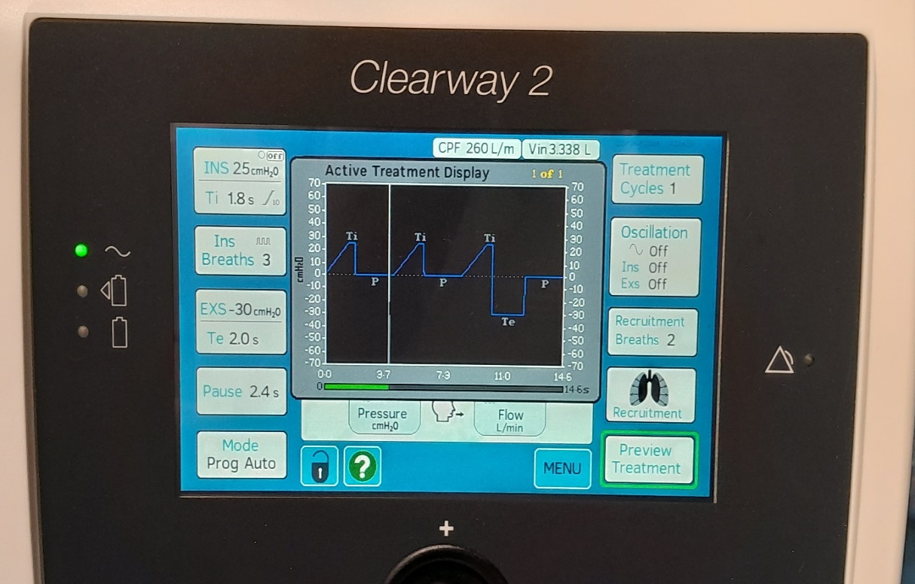

Cough

Relaxed breath out

Breath in

1. Sit up straight with your back and head supported.
2. Turn on the Cough-Assist machine.
3. Place your mask to your face. Ensure there is a tight seal.

|  |  |
| --- | --- |
| **Patient set-up** |  |

1. Take a deep breath **IN** and relax up to 3 times syncing with cough-assist machine. You should feel your chest wall expand.
2. After the third positive breath in, the cough-assist machine delivers a negative pressure breath inducing a cough. Keep the mask to your face when coughing.

**How often should the cough-assist machine be used?**

A cough assist cycle is 3 positive pressure breaths IN followed by a negative breath OUT or a cough. This is followed by 2 more positive pressure breaths (also known as recruitment breaths) to re-inflate the lungs.

We advise you to do ____ cycles of the cough assist _____ times a day. You can use it more if you find it useful.

**Cleaning Equipment**

The face mask should be washed in mild soapy water, rinsed in warm water and then allowed to dry naturally at least once daily. Please ring Respicare on a monthly basis to order new face-masks, filters and tubing. They will be delivered to your home by courier. Phone number Respicare 01-8904020 e-mail: support@respicare.ie

**Contact Details**

Please contact CUH Physiotherapy department if you have any queries re machine settings at 021-492 2405.