 

**Physiotherapy Department**

# 

**Breath Stacking**

**Patient information leaflet**

**What is Breath Stacking?**

Breath stacking is a technique you can use regularly for keeping lungs clear of secretions. People with weak breathing muscles use this technique. A piece of equipment called a Modified Ambu bag is used to help push more air into the lungs as you breathe in.

**The benefits of Breath Stacking?**

* Keeps the lungs clear of secretions
* Helps prevent chest infections from developing
* Keeps lungs and chest wall flexible
* Makes it easier to cough effectively
* Improves voice strength

**What equipment is needed?**

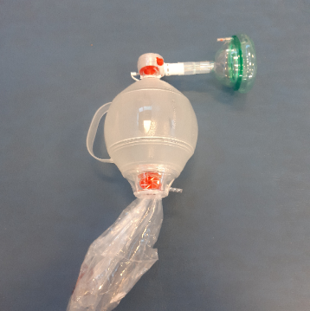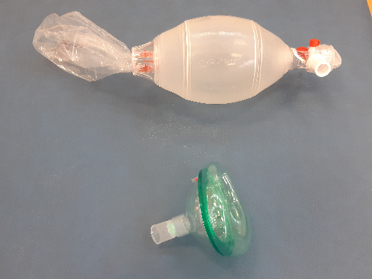

* Modified Ambu bag
* Face mask with a one way valve

This will be assembled for use by your physiotherapist.

Correctly assembled equipment

**Caution**

Only use the Modified Ambu bag under the advice of your physiotherapist as it is not suitable for some respiratory conditions. Do not share breath stacking equipment with anyone as this could spread infection.

**Using Breath Stacking with 1 way valve only (no**

**Modified Ambu bag attached).**

1. 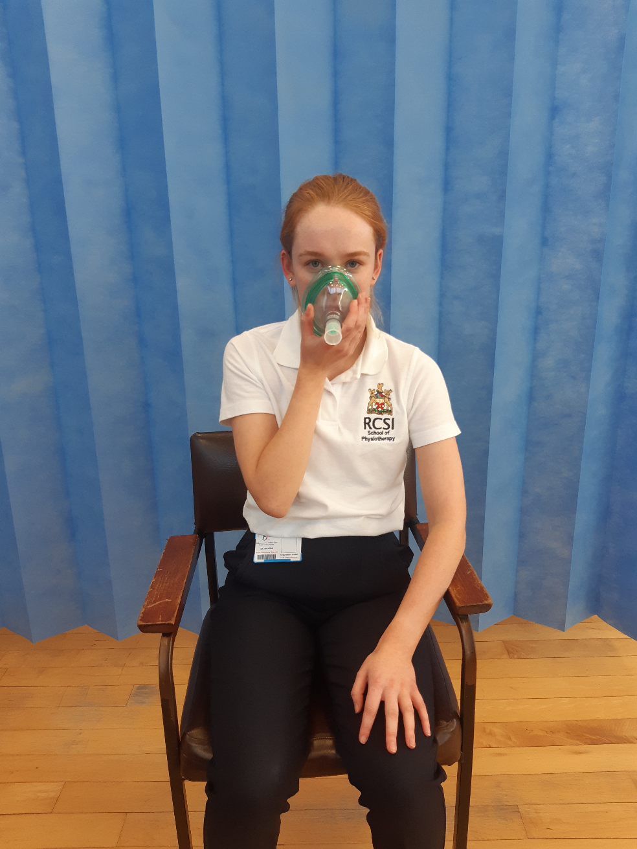Sit up straight with your back and head supported.
2. Place your mask to your face. Ensure there is a tight seal.
3. Take a deep breath **IN,** up to 3 times without leaving a breath out. You should feel your chest expand.
4. Take your facemask away and breathe **OUT** or cough.

**How to complete Breath Stacking?**

(You might need assistance handling the bag)

1. 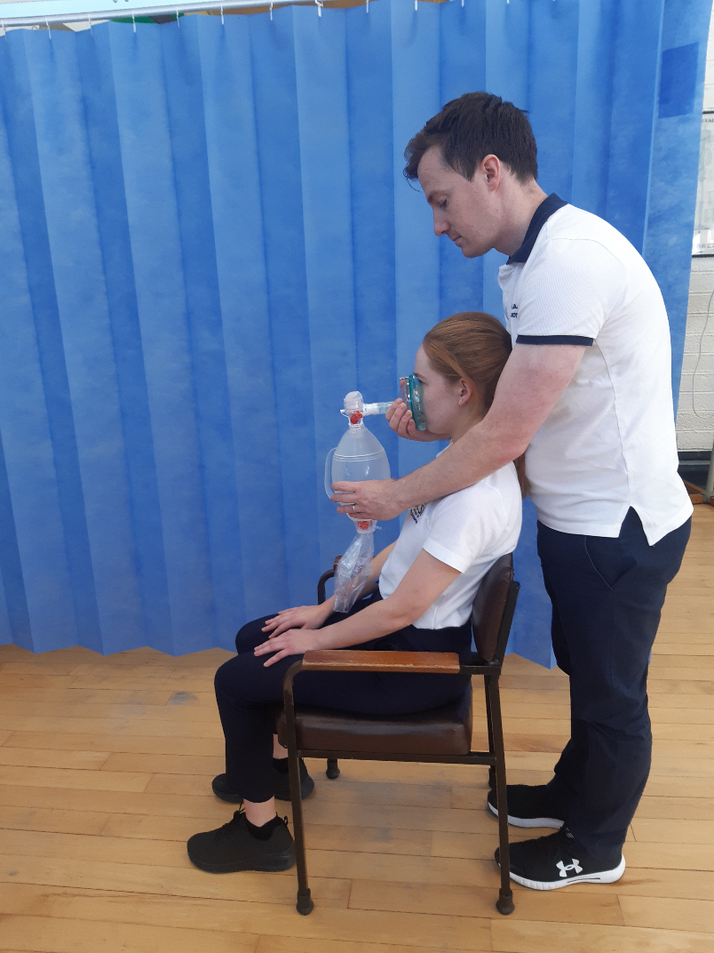Sit up straight with your back and head supported.
2. Hold the face mask firmly to your face.
3. If using an assistant, it is important to coordinate the breath with them. Your assistant may be in front of you or if necessary behind you to aid head control during the technique (see picture)
4. Take a deep breath **IN** while your assistant squeezes the bag.
5. Hold the breath (the one way valve will help this)
6. Then immediately take another breath **IN** on top of the first breath while your assistant squeezes the bag again (stacking one breath on top of the other).
7. Take up to 3-4 breaths **IN** one after the other in this way.
8. Remove the mask and breathe **OUT.**
9. This technique may also be followed by a cough instead of a breath out.

**How often should breath stacking be done?**

A breath stacking cycle is 3-4 breaths IN followed by a breath OUT or a cough.

Do this _______________________ times a day.

**Cleaning Equipment**

The face mask should be washed in mild soapy water, rinsed in warm water and then allowed to dry naturally once a week.

**Contact Details**

Please contact CUH Physiotherapy department if you have any queries at 021-492 2405.