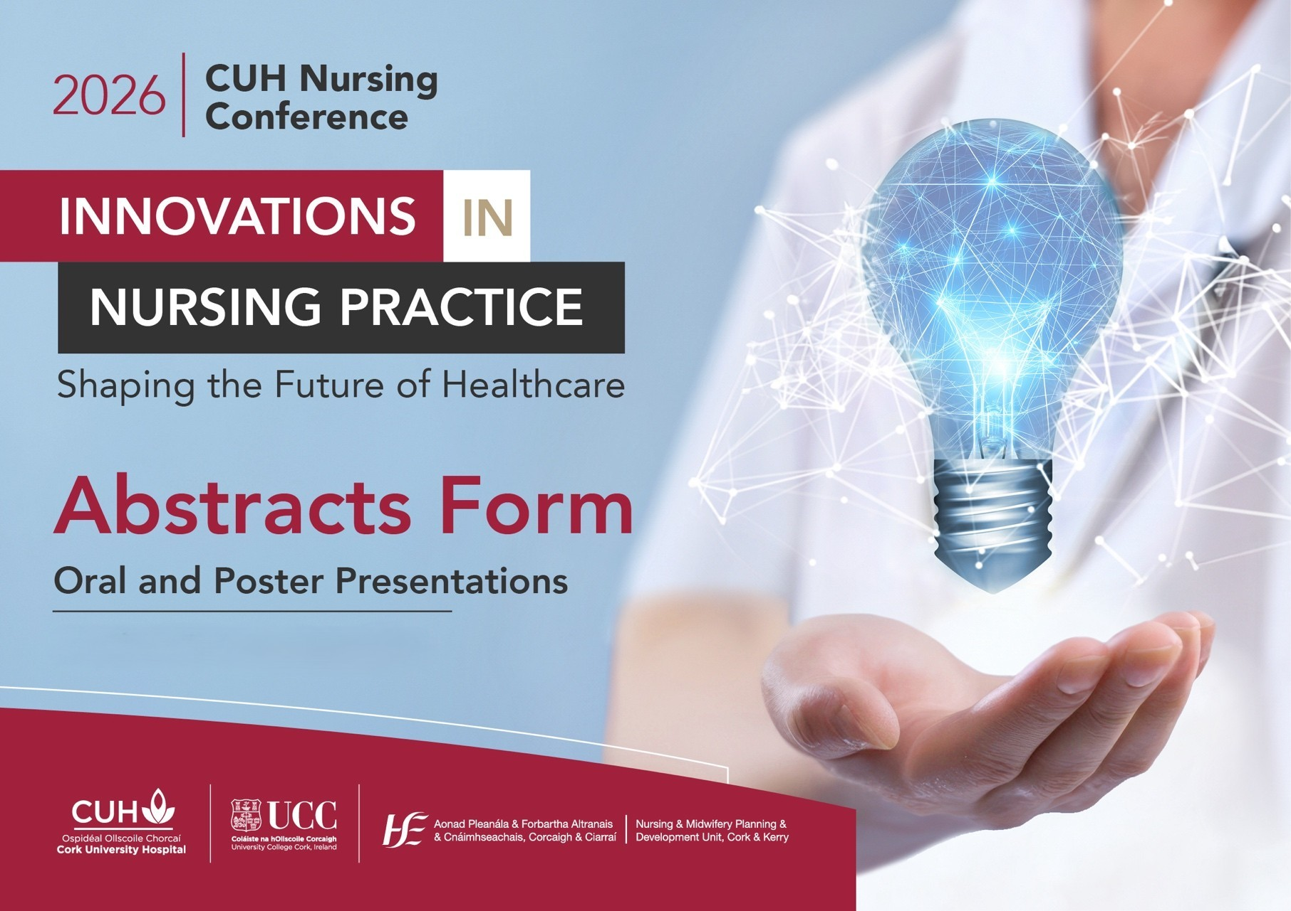

CUH Annual Nursing Conference, Tuesday 24th February 2026

All submissions must be typed clearly. Please avoid diagrams, illustrations, tables, references or graphics in the abstract. The presentation title should not exceed 25 words and body of text for the submission should not exceed 250 words, excluding title, author and references.

Email completed forms to Anju.Menon@hse.ie – Closing Date 1/12/2025

Please ensure all co-authors are aware of the contents of the abstract before submission.

Abstracts will be shortlisted and successful candidates will be notified on the week of 15/12/2025
Presenter (s) Name (s): | Organisation:
Email:

Contact Number:

Please Tick ✓ to indicate if your abstract submission is for:

- Oral Presentation AND/ OR b ) Poster Presentation

Presentation Title:

Background (brief reason/description of the project/research):

Objectives:

Process/Methods /Model of care (as applicable):

Outcomes (Please provide data/results where applicable):

